**Toyo toys**

*User Guide*

|  |  |  |
| --- | --- | --- |
| **Supervisor.** | MISS AMNA SATTAR | |
| **Batch.** | 2301C1 | |
| **Group.** | B | |
| **Serial No.** | **Enrollment Number.** | **Student Name.** |
| 1. | 1445672 | Huzaifa |
| 2. | 1449188 | HUNAIN |
| 3. | 1449272 | ASHAR |
| 4. | 1448244 | DANIYAL |
| 5. | 1448216 | UMAIR |

*ACKNOWLEDGEMENT*

The first, we would like to express my special thanks of gratitude to my teacher Miss Amna Sattar, who helped us a lot in finalizing this project within the limited time frame, valuable counselling and assistance for the accomplishment of this project.

Secondly, we would also like to thank the e Project team at APTECH Head Office, who gave us the golden opportunity to do this wonderful project about Toyo Toys.

Thirdly, we also thank the e Project team, some of the benefits are as under:

• Re-enforcement of skills happens in the experiential learning process.

• A mentor, ensuring that we do not get drifted, constantly guides us.

• It gives us a lot of confidence to face an interview as we have worked on a project.

We can explain virtually everything on the subject we have learnt.

*SYNOPSIS*

Follow the strong development of the internet, technology watches and the growing watch market, every business needs a website design to display products on the internet.

The following TOYOTOYS product are designed with many different designs, suitable for all styles and preferences, which are the most special suggestions from aura watches.

Attached are the introductions hidden behind the watch gift from the gift you want to send to your lover, colleagues or loved ones.

So aura watch shares the best product images through the website for everyone to know.

However, purchases are not made directly on the website.

*PROBLEM DEFINATION*

Toyo Toys is into business of manufacturing and selling toys.

They have been advertising about their clocks and watches through newspapers, pamphlets, television. Now with changing times, they have decided to go online as customers today use Internet extensively. They have planned for a website with complete details about their watches and clocks.

So, we solved many particular queries as followed:

• How the sitemap possibly looks alike?

• What information should be displayed on each page?

• How to put every comment is friendly?

• How to give users the best experience when using the website?

• How to let the website properly functioning along with the system requirement?

• Will the user be able to contact with Aura Watch company for advice?

*CUSTOMER REQUIREMENT*

*SPECIFICATION (CRS)*

After discussion, we are supposed to create a website for them with the below mentioned requirement specifications:

• The Home Page should have suitable logo, and decent color

combination.

• The site should display a menu which will contain the options as Products, Technology etc.

• Various pages having information about different types of toys.

• The information should be categorized according to different ages of products.

• When a user selects any product line-up, complete list of watches for that product line-up will be displayed.

• Details of the watches should be displayed on the Web Page along with the title and it should be stored in Individual Word documents which can be downloaded or viewed by the User who wishes to see the same.

• Price List for all watches should be available for download.

• There should be a “Contact Us” page which will have the Address of the Stores selling watches and the mail address which when clicked will invoke the local mail client from where they can send an

email. Address of the Company should be displayed using Geo Location API (example. Google Maps).

*SCOPE OF THE WORK (IN BRIEF)*

The website is to be developed for the Windows Platform using HTML5, JavaScript Bootstrap and jQuery. The site should work well in all leading browsers including Chrome, IE, Firefox etc.

Homepage show Top best sell items, big sale, collection, new shop...

Every content direct to relative content.

AGGREGATED SITEMAP

TOYO TOYS

(

0

.Welcome.html

)

TOYO TOYS

(

.Index.html

1

)

Aura Watches

Vietnamese

(

1

-

VN.html

)

SITEMAP

TOYO TOYS

1. Index html)

2-3 years old

Home page

(1. Index html)

4-8 years old

Toys by age

8-10 years old

Categories

Pokey

About us

Toys by brand

Disney

Contact us

PAW Petrol

WIREFRAMES

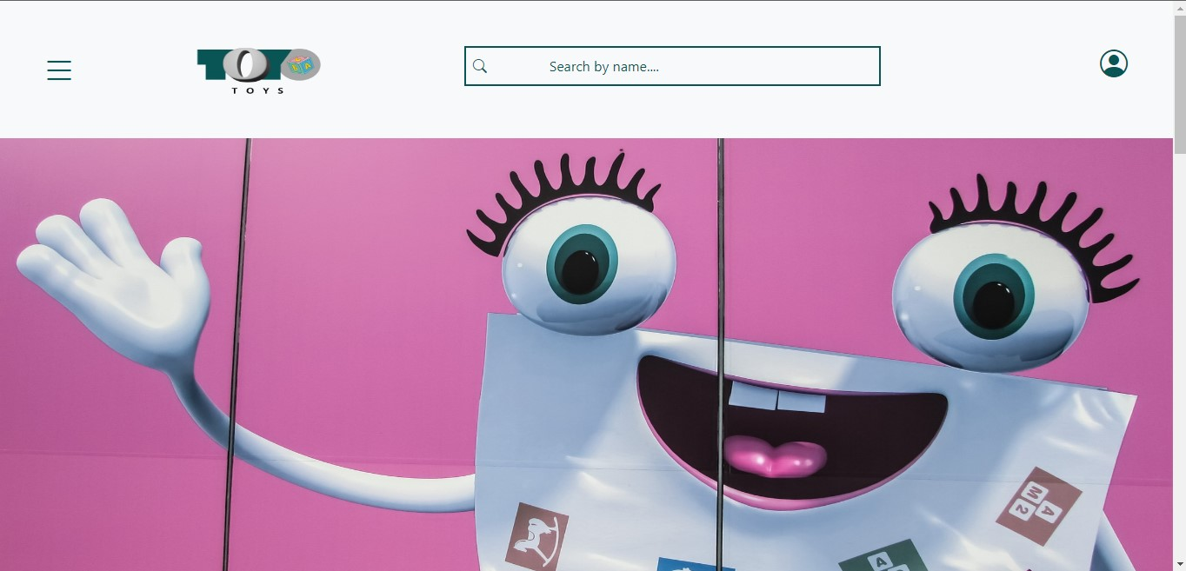

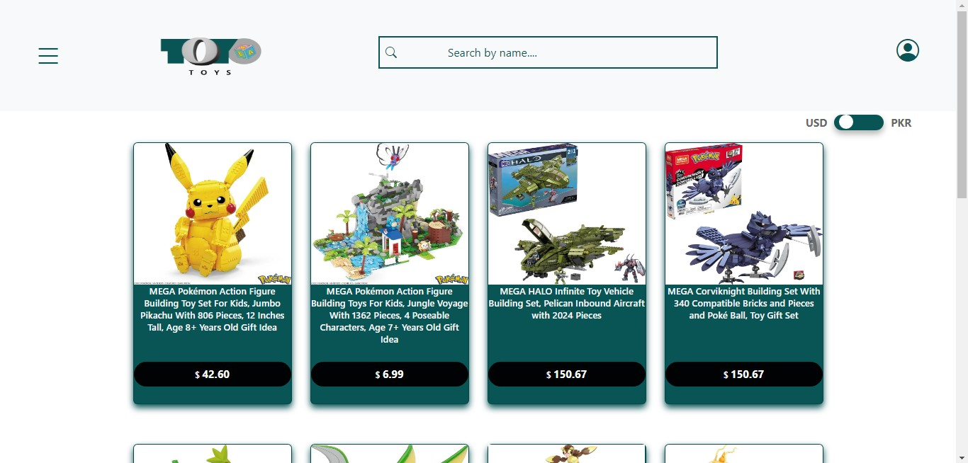

Product Line-Up

❖ Product Line-Up 1: **Toys by Age**

* 2-3 years old
* 4-8 years old
* 8-10 years old

❖ Product Line-Up 1: **Toys by Brand**

* Pokey
* Disney
* Paw Petrol